Name : Fariha Arai

AF ID : AF0443236

Lab 5

**1. Declare a div() function with two parameters. Then call the function and pass two numbers and display their division.**

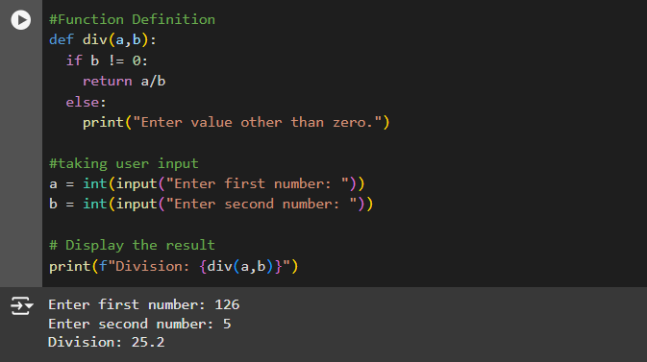

**2. Declare a square() function with one parameter. Then call the function and pass one number and display the square of that number.**

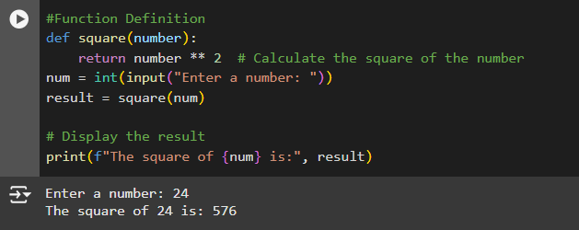

**3. Using max() and min() functions display the maximum and minimum of 5 random numbers.**

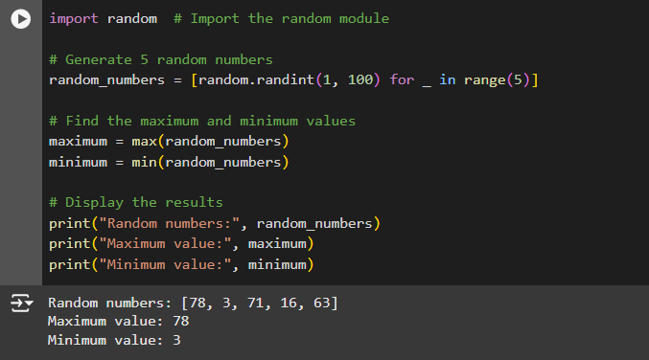

**4. Accept a name from the user and display that in lower case using lower() function.**

